**On Linux:**

* After attaching the volume to linux instance, we can see that storage detains in server with **“lsblk”** command.

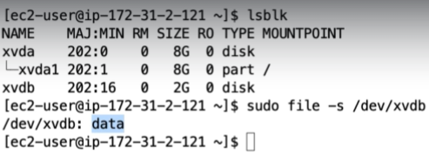

* If we get the output as data with the second command as above, which means there is no file system for that disk. So, we need to create one.

We need to run the below command for that

* **sudo mkfs -t ext4 /dev/xvdb**

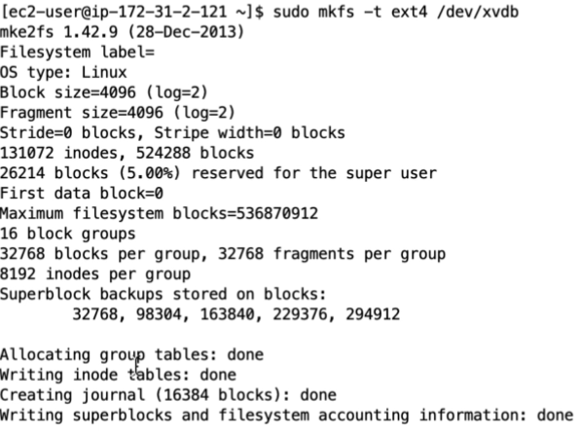

Now, we need to mount that with the below commands.

* **sudo mkdir /data**
* **sudo mount /dev/xvdb /data**

after this, we can see that **xvdb** drive mounted to **/data** folder.

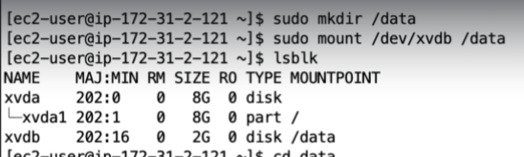

* Now, take the backup of fstab file in **/etc/fstab**. Then edit the original file and add a line as below.
* We need to add the device name, mounth path and the files system type etc.

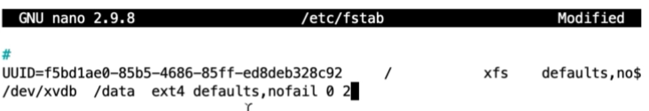

* Now we need to reboot the server to get the changes.
* We can get all this process details in aws website.

<https://docs.aws.amazon.com/AWSEC2/latest/UserGuide/ebs-using-volumes.html>

Below is the command to unmount the disk

* **sudo umount /data**

**On Windows:**

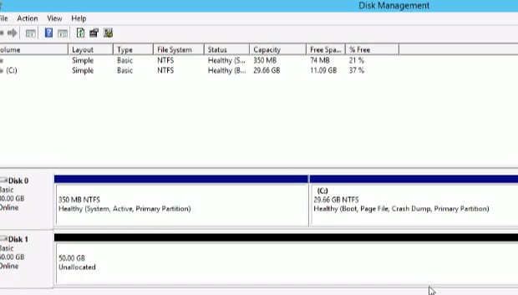

* After this, in windows under disk management, we can see the disk is offline’
* We can make it online and initialise the disk by right clicking on that and allocate that unused space to the hard disk by right clicking on unused space under disk management

**Installing volumes on Linux:**

* **Lsblk to list the block devices**

After adding volume, we can see that with lsblk command

Now, we need to create the file system with that with the below command

* **Mkfs -t ext3 /dev/xvdb**

Now, create a directory and associate that to the file system as below

* **Mkdir /oracle**
* **Mount /dev/xvdb /oracle**

**Mount the filesystem automatically in Linux after every reboot:**

